A. Assign numbers
Taro and Hanako have rabbits, and they want to assign a distinct integer to each rabbit so they can easily identify them.
The rabbits have expressed their preferences to Taro and Hanako. The i-th rabbit wants an integer between 1 and a prefer number, inclusive. Taro and Hanako must obey the preferences of all their rabbits.
Return the number of ways they can assign numbers to their rabbits, modulo 1,000,000,007. If it's impossible to assign distinct integers to the rabbits, return 0.

Input
The first line of the input contains a single integer t (1 ≤ t ≤ 5), the number of test cases, followed by the input data for each test case.
Each test case contains two lines:
Line 1: A integer n(1<=n<=50) which is the number of rabbits.
Lines 2: n integers separate by a blank, the i-th integer is the prefer number of i-th rabbit, each integer will be between 1 and 1000, inclusive.

Output
For each test case, output a single integer, the number of ways they can assign numbers to their rabbits, modulo 1,000,000,007. One line for one test case.

Sample Input
2
1
5
4
4 4 4 4

Sample Output
5
24

B. Travel in Beijing
There are many landscapes in Beijing. Now, ZCC wants to visit all of them.
There are many directed roads between the landscapes and all landscapes are connected. We define a super group that any two point in this group can travel to each other. WE MAKE SURE THAT NO A SUPER GROUP HAVE MORE THAN 7 POINT. ZCC begins his travel at landscapes 0.
Now, give you all the information about the sight spots ,you should give the minim time ZCC have to travel. If he cannot visit all the landscapes, you should output -1;

Input
the first line contain an integer N means there are N landscapes in beijing. (0<N<=70);
The landscape’s number is from 0 to N-1.
the second line contain an integer M means there are M roads follow.(0<M<=2000);
then follow M lines ,every line contains 3 integer u v w means there is a directed road from landscapes u to landscapes v cost ZCC w minutes.(0<=u, v,<N,0<w<=100);There is no two roads have the same u and v.
when N is 0, all test case is finish.

Output
For every test case output the minim time or -1 in a line.

Sample Input
3
2
0 1 3
1 2 3
3
2
0 1 3
0 2 3
0

Sample Output
6
-1

C. WordCount
WordCount is a program for counting every word’s number.
now, we have a distributed program for doing this.
First，the program reads the input file and hash every word to a key in the hash table, and then the program divided the hash table into M part. And every computer get one part and deals all the words in this part. The computer spent 1 second for dealing a word.
Now, we give the hash function ,input file and the number of computer. You should find the minim time for finishing the job.
Here, we define our hash function here.
p=(sum(A*(pos*B+Ascii))%C
pos is the index of the char. The index begin with 1.
Ascii is the AscII of the char.
so ,if A=1 B=1 C=10,
the key of ’abc’ is (1*(1*1+97)+1*(2*1+98)+1*(3*1+99))%10=0

Input
the first number is the test case number T
the first line of every test case contain M(0<M<=1000) A(0<A<100) B (0<B<10000) C(0<C<10000)
then follow the input file and end with the line contain the word END.
every word in the input file is lowercase and there is no more then 100000 words and every word ‘s length is less than 10

Output
For every test case output the minim time for finish the job.

Sample Input
2
1 1 1 10
abc
END
2 1 1 10
abc abc abc
END

Sample Output
1
3

D. Check the team
There is a rectangle with n row and m column. And every grid has a score.
Now,we would give you a series of orders. And your program should give the right answer when the order need.
order | need to do
exchange A B C D | exchange of the number in A row B column and the number in C row and D column
replace A B C | replace the number in A row B column with C (0<=C<=1000)
turn A | let the number at the bottom of column A be the top one
line A B C | output the sum of all the number stand in C row and between column A and column B(include A column and B column and A<=B)
snakelike A B C | output the sum of all the number in the snakelike begin at row C and between column A and column B(include A column and B column and A<=B)
example:
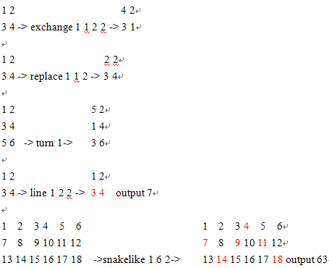
To make it more easy ,at the beginning the number in x row and y column is (x-1)*m+y.
Also, all order is legal.

Input
the first line is the number of the test case T(0<T<=5) then follow T test case;
the first line of the test case contains 3 integer n m o meanings n row, m column and o orders follow (2<=n<=5,0<m<=100000,0<o<=10000);
the next n lines every lines contain an order.

Output
output when you meet order line or snakelike. Remember every answer should output in a line.

Sample Input
1
3 6 5
snakelike 1 6 2
exchange 1 1 2 2
replace 1 3 100
turn 4
line 1 6 1

Sample Output
63
137

E. Binary Tree
For the binary tree, the corresponding sequential representation would be as follows (assuming that ‘/’ stands for NULL):
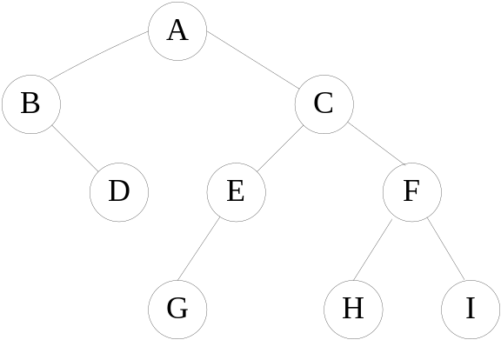AB/D//CEG///FH//I//

To reconstruct the binary tree structure from this node list, we begin by setting node A to be the root. A’s left child will be node B. Node B’s left child is a NULL pointer, so node D must be B’s right child. Node D has two NULL children, so node C must be the right child of node A.

Input
* Lines 1: the string of the sequential representation

Output
* Line 1..M: print the node values of the binary tree in level order.

Sample Input
AB/D//CEG///FH//I//

Sample Output
A
BC
DEF
GHI

F. The +- Programming Language
Have you ever heard the big name of the +- programming language? I don't think you have. Until now I am the only man who knows the language.
However, the language is very simple and something stupid, because the only operators in the language is '+'(plus), '-'(minus), and the only type of the language is unsigned int, length 32 bit.
Here are the grammar rules of the language:
Variable := [a-z]+
Integer := [0-9]+
Operand := <Variable | Integer>
Operator := [+-]
Expr := <Operand> | <Operand> <Operator> <Expr>
Operation := <Variable> = <Expr>
Query := <Variable>
The meaning of +,-, = are the same as they are in C/C++/Java.
However, the most powerful feature of the +- language is that it is OROP, or Object Relationship Oriented Programming, that is if we have A=1, B=A, when the value of A changes to 3, the value of B will change to 3 as well. Of course, since the design goal of the language is very rational, the relationship of A=B and B=A will lead to the explosion of the computer – so the programmer will never make this mistakes.
Being a little confused? I've got some sample code of the +- language.
a=1
b=2
c=a+b-3
c
a=2
c
d
and the output of the code will be:
c=0
c=1
d=0
And now it's your turn to write down the first ever interpreter for the +- language in world.

Input
The input file contains the source code from some +- language source file. No input will be larger than 1000 lines. An Expr will contain 10 Operands at most.

Output
For each Query in the code, print the string in a single in the style showed above.

Sample Input
a=1
b=2
c=3
a
b
c

Sample Output
a=1
b=2
c=3

Hint
1. Our judge computer will not explode.
2. [a-z]+ means one or more lower case English alphabet character.
3. The length of the name of variable will be fit in 10 bytes.

G. Apple fan
CC is an apple fans. His house is around apple tree. He likes picks the apple and take back to home. And He may eat the best apple or throws the worse apple.

Input
the First line contain a Integer N (0<=N<=1000000)
the follow N lines, every line begin a word.
the word can be pick, eat or throw
if the word is “pick”, an Integer A (0<A<2^31)would follow means this apple’s score is A
if the word is “eat”, means he eats the apple
if the word is “throw”, means he throws the apple

Output
when you get the word “eat”, you should output the best score in CC’s home or -1 if there is no apple at home
when you get the word “throw”, you should output the worse score in CC’s home -1 if there is no apple at home
every answer should be print in a line.

Sample Input
9
eat
pick 1
pick 2
pick 3
pick 4
pick 5
eat
throw
eat

Sample Output
-1
5
1
4

H. Mailing List
William is collecting a mailing list for the promotion of his company. Before adding a new email to the mailing list, he wants to check if that email already exists in the list.

Input
First line is the number of emails in the mailing list represented by integer N (0 ≤ N ≤ 5000). Each email in the mailing list is given in following lines.
Next line is the number of new emails represented by integer M (1 ≤ M). Each new email is given in following lines.
Each email contains alphabet letters (either lowercase or uppercase), underscore, dot, and @. The length of each email will be no more than 30 characters.

Output
For each new email, if that new email already exists in the mailing list, return “Yes”. Otherwise, return “No”.

Sample Input
5
vis@126.com
sbv@gmail.com
567464534@qq.com
huchavi@scut.edu.cn
13784455555@139.com
2
vis@126.com
sbk@gmail.com

Sample Output
Yes
No

I. Quintet
Quintuples (<X1, X2, X3, X4, X5>) can be used to describe a point in 5-Dim space, such as <19, 89, 8, 1, 0>. Given two quintuples A, B, the distance between A and B is defined as following:
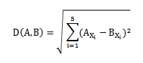
Now given a set of quintuples S and a quintuple C, R is defined as following:
R=max{D(C,P)|P∈S}
Now you are to find a C, such that R will be the minimum.

Input
The input file contains several test cases. For every test cases, the first line of the input is an integer N (1<=N<=40), the count of elements in the set. The next N line, each line describes a quintuple. End of file indicates the end of input.
The number of test cases will not be larger than 30.

Output
For each test case, output a line with an r, where the r is the corresponding R of the C you find, the r should be rounded to 2 digits after the decimal point.

Sample Input
2
0 0 0 0 0
1 1 0 0 0

Sample Output
0.71

J. HugeInteger Class

Create a class HugeInteger that uses a 40-element array of digits to store integers as large as 40 digits each. Provide member functions input, output, add and substract.

Input
Enter 4 HugeInteger number from the keyboard.

Output
Print the first result that the first HugeInteger number add the second HugeInteger number, and print the second result that the third HugeInteger number substract the fourth HugeInteger number.

Sample Input
1111111111111111111
2222222222222222222
5555555555555555555
4444444444444444444

Sample Output
3333333333333333333
1111111111111111111

Hint
The input and the output HugeInteger number do not exceed 40 digits.

K. Prime Ring Problem
A ring is composed of n circles as shown in diagram. Put natural number 1, 2, ..., n into each circle separately, and the sum of numbers in two adjacent circles should be a prime.
Note: the number of first circle should always be 1.
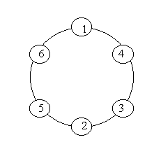
Input
n (0 < n < 20)

Output
The output format is shown as sample below. Each row represents a series of circle numbers in the ring beginning from 1 clockwisely and anticlockwisely. The order of numbers must satisfy the above requirements. Print solutions in lexicographical order.
You are to write a program that completes above process.
Print a blank line after each case.

Sample Input
6
8

Sample Output
Case 1:
1 4 3 2 5 6
1 6 5 2 3 4

Case 2:
1 2 3 8 5 6 7 4
1 2 5 8 3 4 7 6
1 4 7 6 5 8 3 2
1 6 7 4 3 8 5 2

L. In Sunshine
When CBD came to the City of Tapers, he found that all the buildings in the city were in the shape of a cone. Though the sun is high up in the sky, not every corner is bright. Now we know the coordinate of the sun, and where CBD is, I want you to tell me whether CBD is in sunshine.

The coordinate of the sun or CBD is described as a triple (X, Y, Z,),where 0<=Z<=100000 , which is corresponded to a unique position in our space. The buildings of the city all stand on the ground and are in cone shape. For any building, we know its high (h), 0<h<1000, radius(r) < 1000, and the position of its bottom’s center(X, Y, 0). You can be assured that the top of a building will be at (X, Y, h).

Of course the sun is higher than anything. All of the input number will be fit in a 32-bit integer.

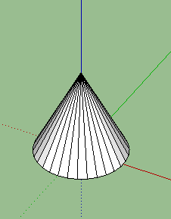
Figure: A cone

Input
The input file contains several test cases. For each test case, the first line is three integers X, Y, Z, the position of the sun; the second line is also three integers, which describes the position of CBD. Then it will be an integer N (N<1000), for each line of the coming N lines, there will be 4 integers, h, r, X, Y.
EOF indicates the end of the input.

Output
For each test case, output 1 or 0, indicates whether CBD is in sunshine.

Sample Input
20 0 30
-20 0 10
1
20 10 0 0

20 0 30
-20 0 0
1
20 10 0 0

Sample Output
1
0

